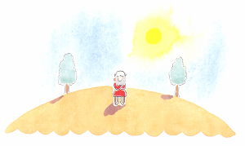
There were no animals or people on the island so
The hermit had it all to himself… which was just
How he liked it.
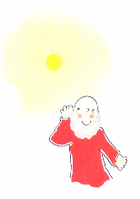
It was always quiet…
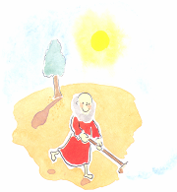
…always tidy…
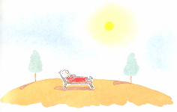
…always peaceful.
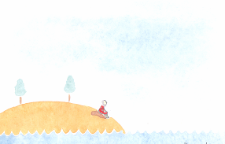
But one day…
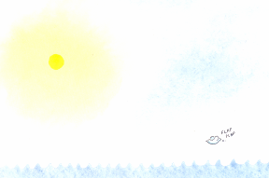
…he had a visitor.
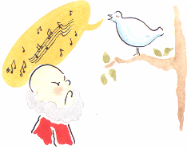
Soon it wasn’t quiet…
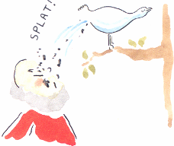
…or tidy…
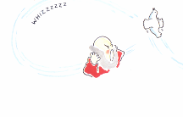
…or peaceful.
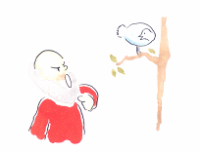
‘This is my island,’ said the hermit. ‘Go find your own.’ ‘There are no other islands,’ said the bird.
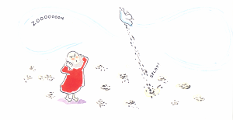
So they had to share. But the hermit didn’t like sharing. He wanted his own bit of island. ‘We’ll divide the island in two,’ he said.
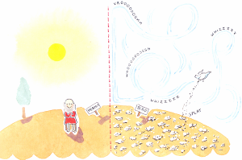
So they tried it, and it worked…
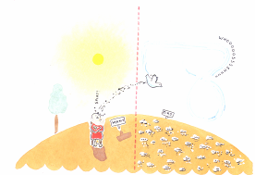
…for a while.
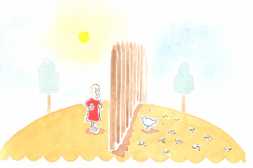
Finally, the hermit built a wall.
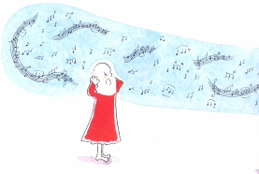
But it was no good.
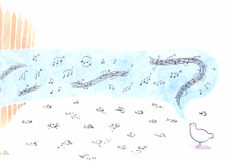
The bird had to go.
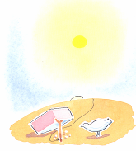
The hermit built a trap…
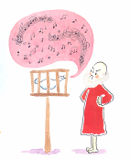
…and then he built a cage…
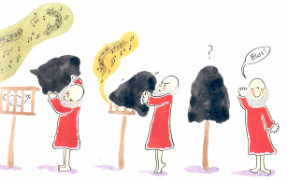
…and then he made a hood to put over the cage until…at last… there was silence.
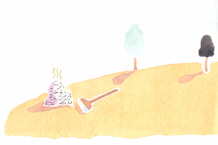
He tidied the island, lay in the sun and listened to the silence.
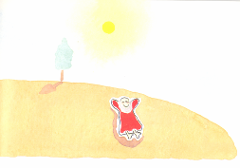
But after a while the silence bothered him…he even missed the bird’s song.
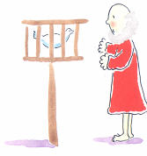
‘Please sing,’ said the hermit. But the bird wouldn’t.
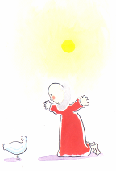
‘Please make a splat,’ said the hermit. But the bird wouldn’t.
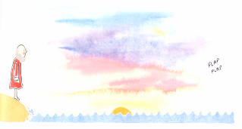
‘Please don’t fly away,’ said the hermit. But the bird did.
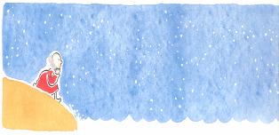
Now it was very quiet. The hermit grew lonelier and lonelier, and wished the bird would come back.
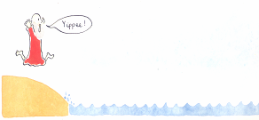
He waited and waited for days…until…
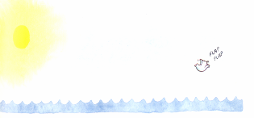
…at last…
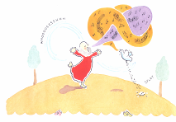
‘Oh it’s so nice to share with a friend,’ said the hermit. ‘Yes. There’s nothing like sharing with a friend,’ agreed the bird.
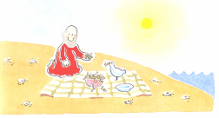
‘In fact… that’s why I went back to get the others.’ ‘Others?’ said the hermit.
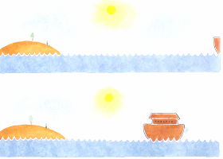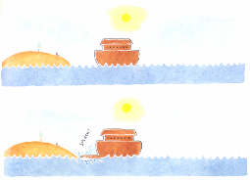
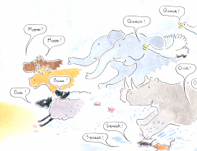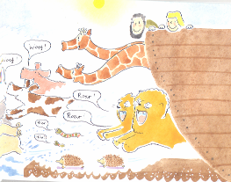
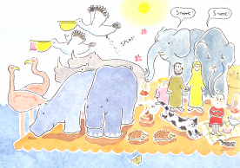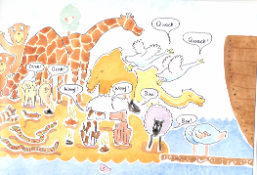
Yes, the others…
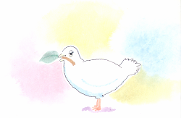
…Said the Dove.

